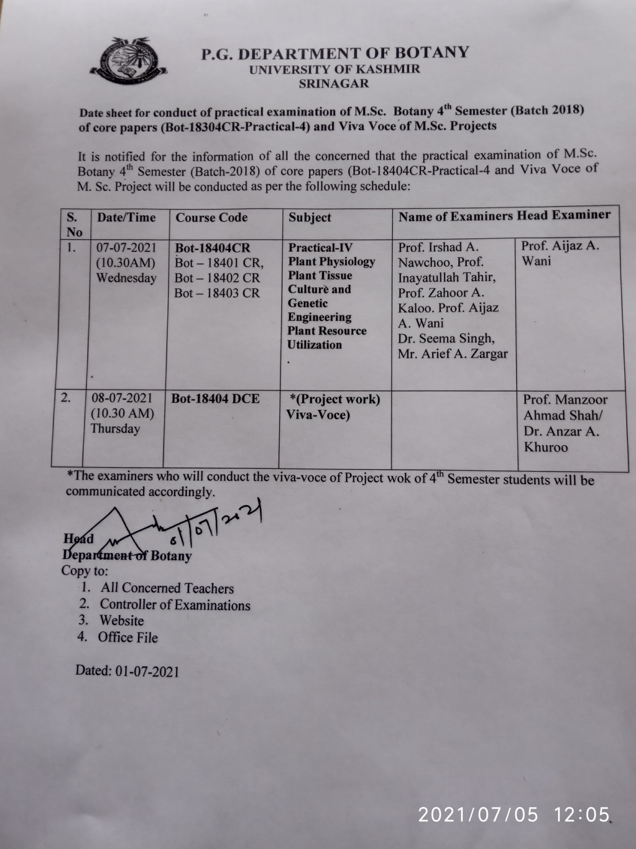

Sub: Authorization for Expert Committee pertaining to Upgradation of Ms. Anees Un Nisa (CSIR -JRF) from JRF to SRF.
In the light of the subject captioned above, the following committee may be authorized for the assessment of research work pursued by Ms. Anees Un Nisa so that she could be upgraded from JRF to SRF as per rules.

Prof. Abdul Hamid Wani
Head, Department of Botany
University of Kashmir, Sgr

Dr. Mushtaq Rasool
College of Temperate Sericulture
Sheri-Kashmir University of Science and Technology
Mirgund Pattan

Professor Ali Anwar
Division of plant pathology
Sheri-Kashmir University of Science and Technology
Shalimar campus srinagar

Dr. M. Ayoob Mantoo
Professor and Head
Division of Entomology
Faculty of Agriculture SKUAST-Kashmir
Wadura campus Sopore

Head
Department of Botany

Dean
School of Biological science

Dean Research

Sub: Authorization for Expert Committee pertaining to Extension for 5th year of Zeenat Ismail. (SRF Fellow)
In the light of the subject captioned above, the following committee may be authorized for the assessment of research work pursued by Zeenat Ismail so that she could be given extension for 5th year as per rules.

Prof. Abdul Hamid Wani
Head, Department of Botany
University of Kashmir, Sgr

Dr. M. Ayoob Mantoo
Professor and Head
Division of Entomology
Faculty of Agriculture SKUAST-Kashmir
Wadura campus Sopore

Dr. Mushtaq Rasool
College of Temperate Sericulture
Sheri-Kashmir University of Science and Technology
Mirgund Pattan

Professor Ali Anwar
Division of plant pathology
Sheri-Kashmir University of Science and Technology
Shalimar campus srinagar

Head
Department of Botany

Dean Research

Sub: Authorization for Expert Committee pertaining to Upgradation of Mr Showkat Nissar (UGC-CSIR -JRF) from JRF to SRF.
In the light of the subject captioned above, the following committee may be authorized for the assessment of research work pursued by Showkat Nissar so that he could be upgraded from JRF to SRF as per rules.

Prof. Abdul Hamid Wani
Head,
Department of Botany
University of Kashmir, Sgr

Prof. Showkat Ara
Head
Division of Environmental Science
SKUAST-Kashmir

Prof .Mohammad Abu Bakar Siddique
Dean Student welfare
SKUAST-Kashmir

Prof. Farooq Ahmad Lone
Ex- Head
Division of Environmental Science
SKUAST-Kashmir

Supervisor

Head
Department of Botany

Dean
School of Biological science

Dean Research

